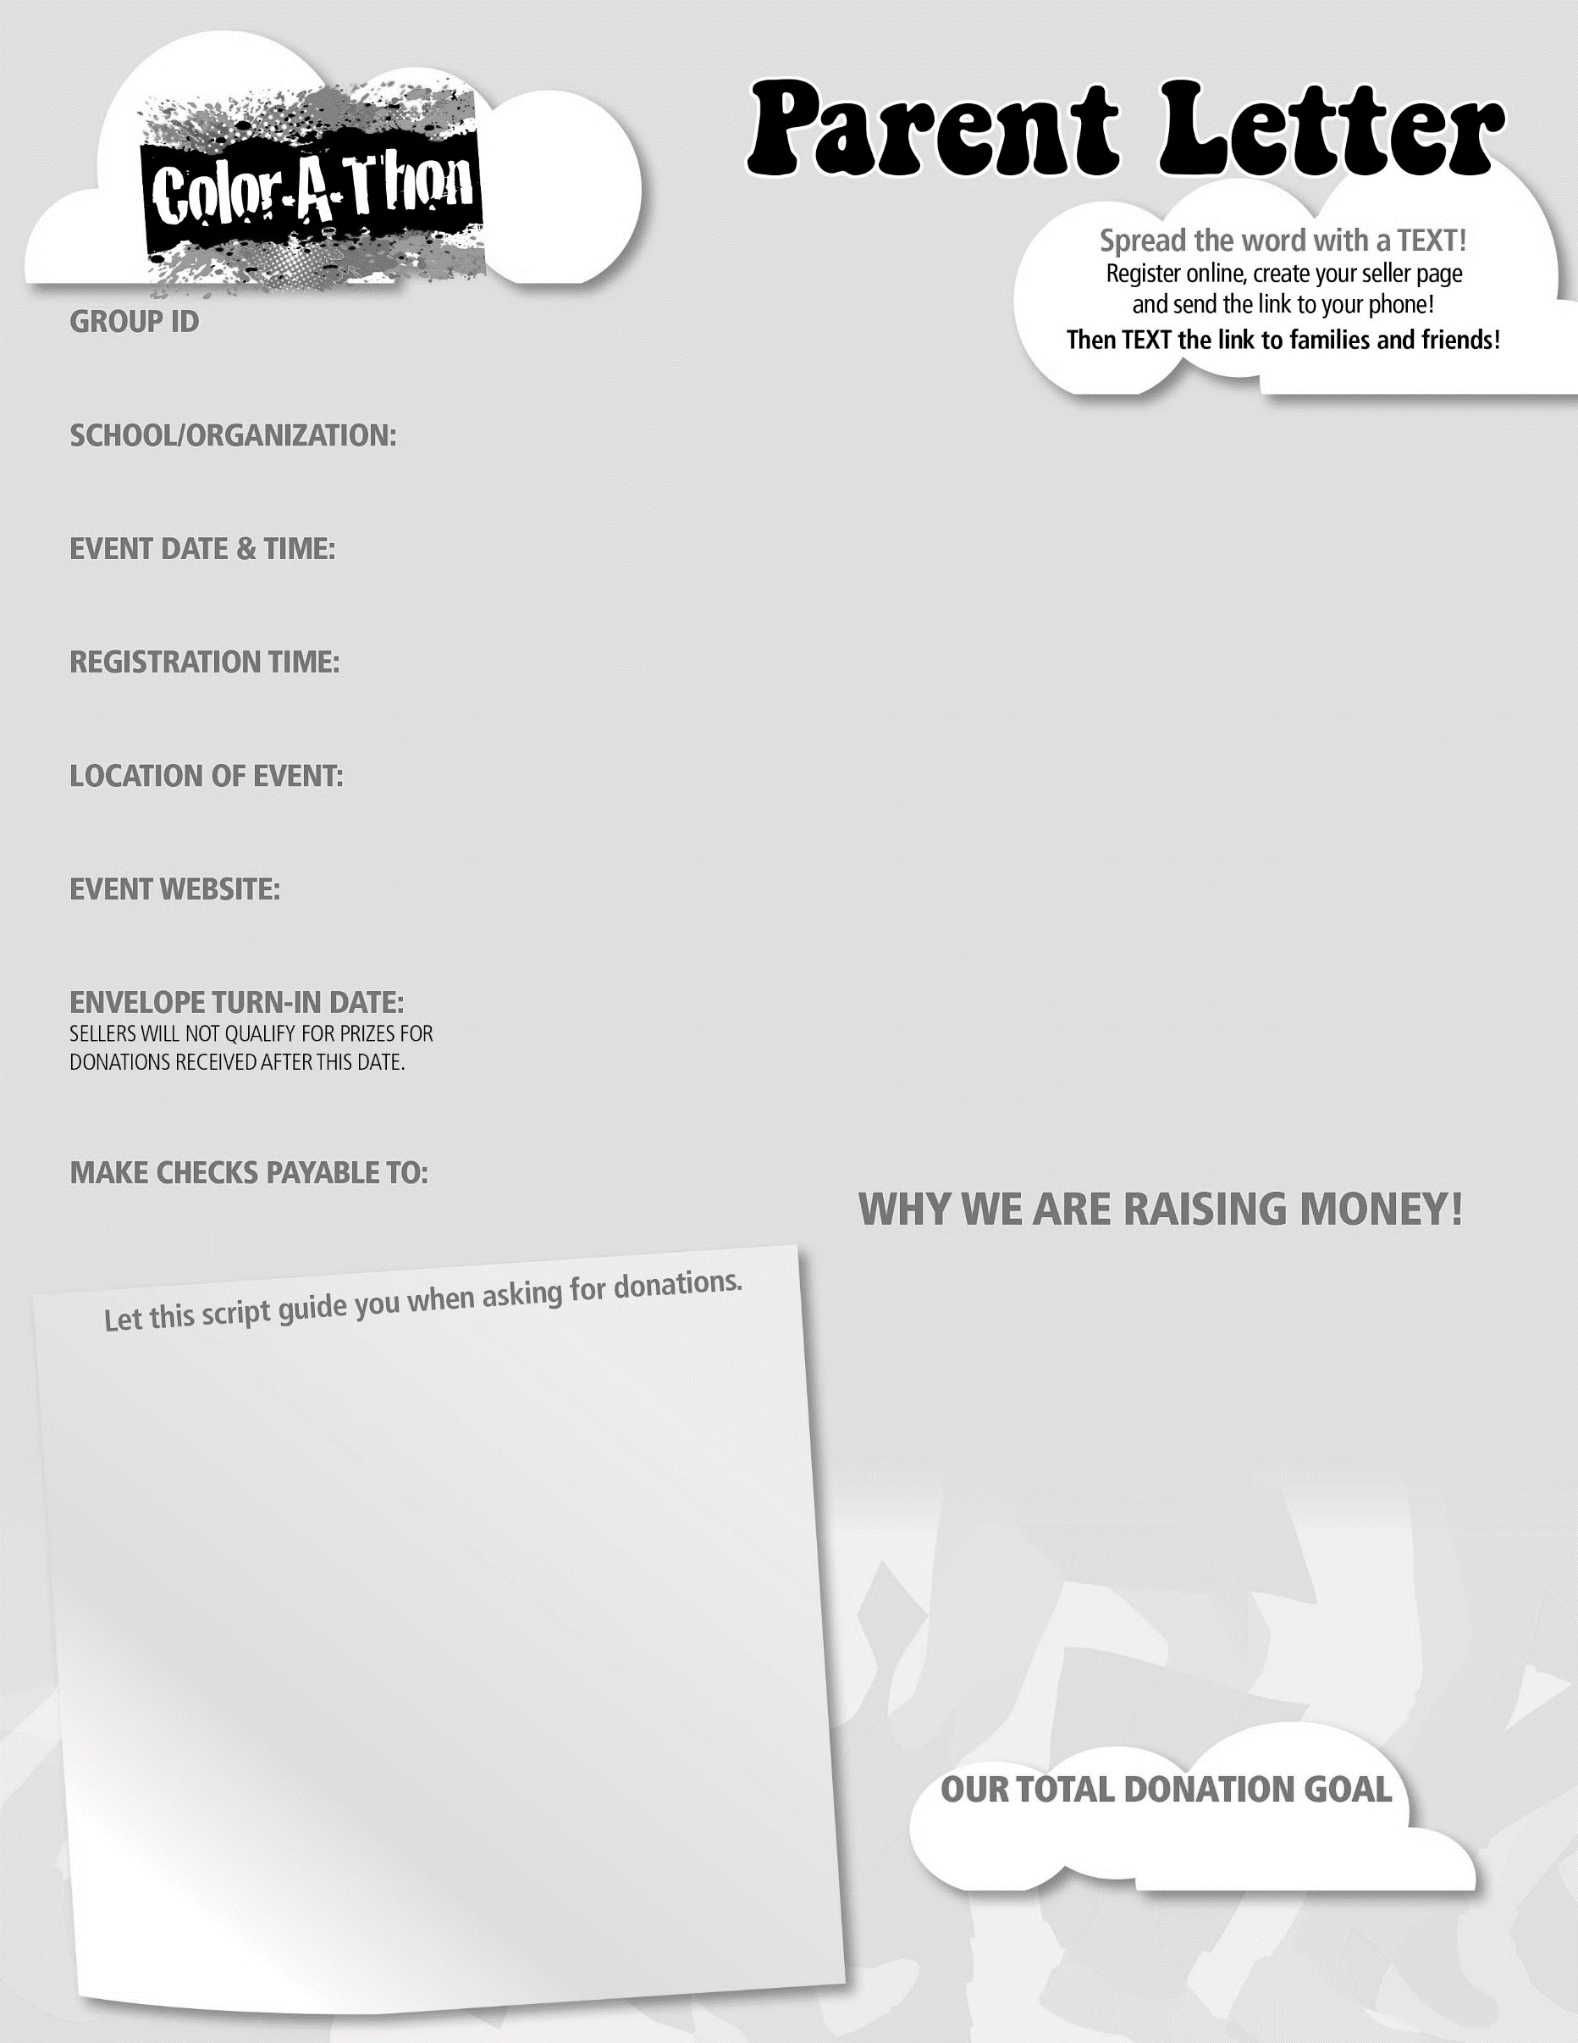

**October 12, 2018 at 5:15 PM**

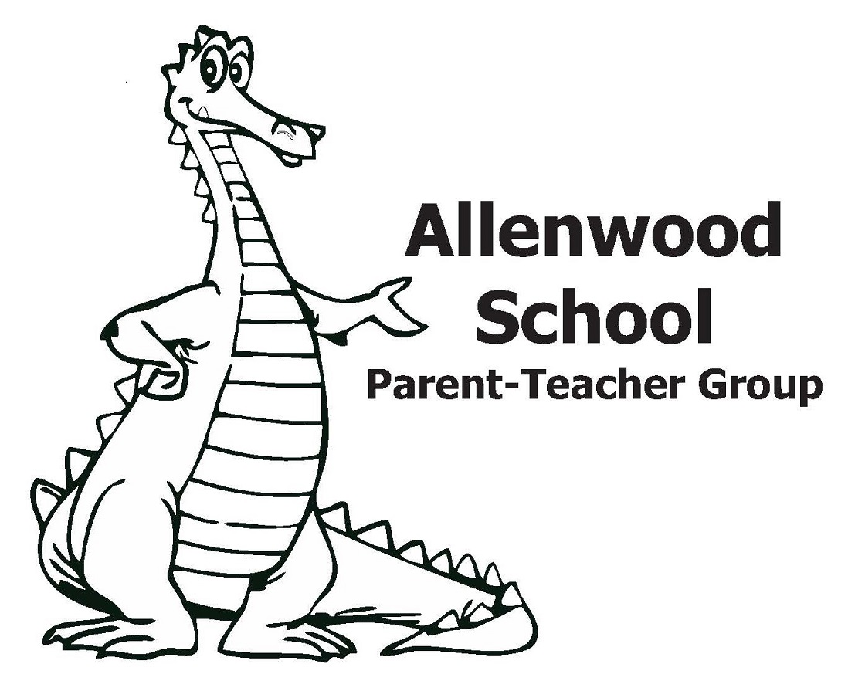

**Allenwood School PTG**

**September 26, 2018**

**4:30 PM**

**Allenwood School PTG**

**Funds raised from this event will go towards the Allenwood School Playground Project.**

**Allenwood School PTG Color Run Info:**

*\*\*Students need to have at least* ***$30*** *in donations by* ***September 26, 2018*** *to be guaranteed a t-shirt, color-me-glasses and color pack. \*\**

Create your own Color Club! Up to 6 additional friends and family members can participate for **FREE** when your child raises donations. You will find the Color Club Insert in your Donation Envelope.

Be sure to register online at [www.schoolathon.org](http://www.schoolathon.org) and use your group I.D.

Our school’s donation goal per student is $100 **AND** when your child receives donations they will earn **GREAT REWARDS**!

Thank you for participating in our Color-A-Thon event!

**Questions?**

**Contact Courtney Alesso at calesso@optonline.net**

**School-A-Thon Customer Service**

**732-525-8333**

**Hello! My name is _______________________**

**I am a student at Allenwood School and am asking for donations to raise money for the Allenwood School Playground Project.**

**At the end of our donation drive, we will be celebrating with a Color-A-Thon event where we get blasted with color dust as we head toward the finish line!**

**My goal is to raise $100.**

**Can I count on you for a $10, $20 or $30 donation?**

**Thank you for your support! I really appreciate it and so does everyone at my school.**

**$100 per student**

**120856**

**Allenwood School Grounds**

**3301 Allenwood-Lakewood Rd, Allenwood, NJ.**

**http://shop.schoolathon.org/190204**