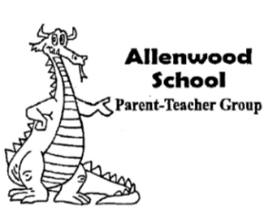
3301 Allenwood- Lakewood Road ● www.awptg.org ● info@awptg.org
ALLENWOOD PTG AGENDA October 22, 2019 Meeting 7:00pm (School Cafeteria)
CALL TO ORDER
SALUTE TO THE FLAG
INDUCTION OF NEW BOARD MEMBER
- 2nd Vice President- Grace Green
OFFICERS’ REPORTS
- President’s Report
- Vice President’s Report
- Treasurer’s Report
PRINCIPAL’S REPORT
COMMITTEE REPORTS
- BYOP & Trunk or Treat- Bryn Magee
- Dining Out- Andrea Cocco
- Spirit Wear- Lauren Chasinov/ Karen Lunder
- Food Allergy Committee- Sharon Zanette
OTHER BUSINESS
ANNOUNCEMENTS
- 10/25- Spirit Day
- 10/25- BYOP & Trunk or Treat, 5:30- 7:00pm
- 10/31- Allenwood Halloween Parade, 2:00pm/ Halloween Parties determined by class
- 11/1 & 11/4- 11/6- Early Dismissal (Teacher Conferences), 1:05pm
- 11/7-11/8- School Closed (NJEA Convention)
- 11/12- Battleview Orchard Pie Orders Due
- 11/14- 11/15- Dragon’s Den
- 11/15- Fall Clothing Drive, 4:00- 7:00pm
- 11/19- Dining Out- Applebees, 11:00am- 9:00pm AND Pastosa Night…. Your Choice!
- 11/22- Spirit Day
Next PTG Meeting will be held TUESDAY, 11/26/19 at 7:00PM in the cafeteria
ADJOURNMENT

