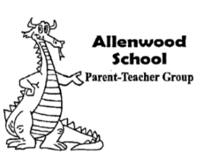
3301 Allenwood- Lakewood Road ● www.awptg.org ● info@awptg.org
ALLENWOOD PTG AGENDA January 16, 2020 Meeting 6:30pm (School Cafeteria)
CALL TO ORDER
SALUTE TO THE FLAG
OFFICERS’ REPORTS
- President’s Report
- Vice President’s Report
- Treasurer’s Report
PRINCIPAL’S REPORT
COMMITTEE REPORTS
- Winterfest- Grace Green
- Yearbook- Kristin Coman
- Theatre Club- Kristin Coman
- TerraCycle- Lauren Galok on behalf of Melanie Cortese
- Gertrude Hawk- Lauren Galok on behalf of Mandy Roarty
- Pocketbook Bingo- Megan McCay
OTHER BUSINESS
- Board to consider alternative times to hold monthly PTG meetings
ANNOUNCEMENTS
- 1/20- School Closed
- 1/21- Dining Out- Fins, 11am- 9pm and Pastosa Night
- 1/22 & 1/23- Dragon’s Den School Store open during recess
- 1/24- Winterfest Ticket Sale ends
- 1/24- Gertrude Hawk Sale begins
- 1/27 & 1/28- Early Dismissal, 1:05pm
- 1/31- Spirit Day
- 1/31- Winterfest, 6:00- 7:30pm at WIS
- 2/6- Jump Rope for Heart Kickoff Assembly
- 2/14 & 2/17- School Closed
- 2/20- Yearbook Orders with Back Cover Personalization due

Next PTG Meeting will be held THURSDAY, 2/20/2020 at 7:00PM in the cafeteria
ADJOURNMENT

