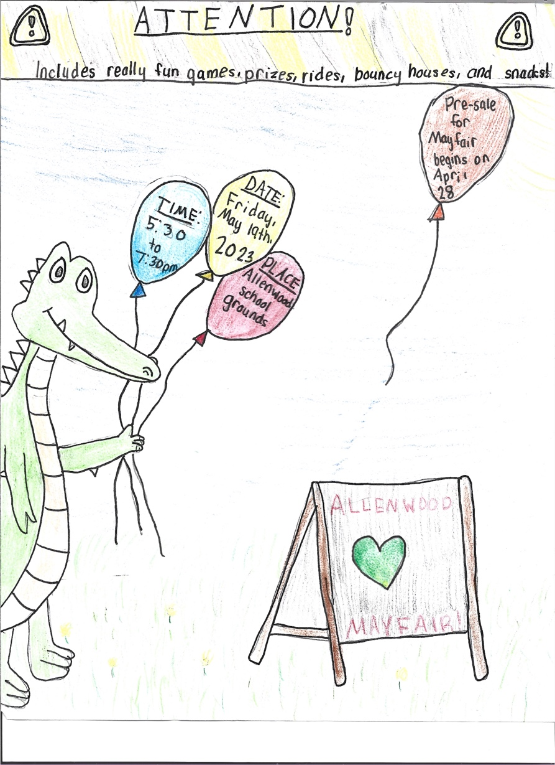

The Mayfair is a family friendly event! Wristbands are needed for children only, and provide unlimited access to traditional carnival games, prizes and inflatables. There will be rides that are appropriate for all ages. Meet Allenwood’s dragon mascot, Skittles. Refreshments will be available. There will be a craft table, and a balloon artist to entertain our dragons. Don’t forget to visit our dunk tank and take a chance at soaking some of your favorite teachers. We will be continuing our sensory friendly Mayfair time for families with children who benefit from a less crowded and sensory inclusive fair experience. This will take place from 5:00 pm-5:30pm. During this time, the fair will have limited lighting effects and sounds. Guests are welcome to stay until the conclusion of the fair.

Presale wristbands will go on sale on April 28th at [www.awptg.org](http://www.awptg.org) or visit <https://digitalpto.wufoo.com/forms/x1msnba00w73kgg/>. Limited number of wristbands available!

If you have any questions regarding Mayfair, please contact Lauren Chasinov at lchasinov@awptg. or Cindy Cimino at [ccimino@awptg.org](mailto:ccimino@awptg.org). Wristbands will be sent home with students the week of the Mayfair.

**Artwork Created by Lucy McInnes, 4th** **Grade** Gradegrade

**2023 Mayfair Wristband Pre-Sale**